# Accessing SMAP Data

## Objectives

By the end of this exercise, you will be able to:

* Access SMAP data
* Visualize and analyze SMAP data

## Outline

1. SMAP Data Background Information
   1. SMAP Data Products
   2. SMAP Data Product Summary
   3. Product Configuration
   4. Sites to Discover, Download, and Visualize SMAP Data
2. Downloading the Data for this Exercise
3. Analyzing the Data
   1. Opening a SMAP File in Panoply
   2. Extracting SMAP Soil Moisture Values
4. Part 1: SMAP Data Background Information

**Part 1A: SMAP Data** **Products**

|  |  |  |  |
| --- | --- | --- | --- |
| Data Product  Short Name | Description | Grid Resolution | Granule Extent |
| L1A_Radar* | Parsed Radar Instrument Telemetry |  | Half Orbit |
| L1A_Radiometer | Parsed Radiometer Instrument Telemetry |  | Half Orbit |
| L1B_S0_LoRes* | Low Resolution Radar σo in Time Order | 5x30 km  (10 slices) | Half Orbit |
| L1C_S0_HiRes* | High Resolution Radar σo on Swath Grid | 1 km | Half Orbit |
| L1B_TB | Radiometer TB in Time Order | 39x47 km | Half Orbit |
| L1C_TB | Radiometer TB | 36 km | Half Orbit |
| L2_SM_A* | Radar Soil Moisture (includes Freeze-Thaw ) | 3 km | Half Orbit |
| L2_SM_P | Radiometer Soil Moisture | 36 km | Half Orbit |
| L2_SM_AP* | Active-Passive Soil Moisture | 9 km | Half Orbit |
| L3_FT_A* | Daily Global Composite Freeze/Thaw State | 3 km | North of 45° N |
| L3_SM_A* | Daily Global Composite Radar Soil Moisture | 3 km | Global |
| L3_SM_P | Daily Global Composite Radiometer Soil Moisture | 36 km | Global |
| L3_SM_AP* | Daily Global Composite Active-Passive Soil Moisture | 9 km | Global |
| L4_SM | Surface & Root Zone Soil Moisture | 9 km | Global |
| L4_C | Carbon Net Ecosystem Exchange | 9 km | North of 45° N |

*Only available during the 2.5 months of radar operation (mid-April – July 7, 2015)

**Part 1B: SMAP Data Product Summary**

|  |  |  |  |
| --- | --- | --- | --- |
| Data Product | Description | Grid Resolution | Algorithm Source |
| L1A_Radiometer | Radiometer Data in Time-Order | - | Mission DA |
| L1B_TB | Radiometer TB in Time Order | 39x47 km | Mission DA |
| L1C_TB | Radiometer TB in Half-Orbits | 36 km | Mission DA |
| L1C_TB_E | Radiometer TB in Half-Orbits, Enhanced | 9 km | Mission DA |
| L2_SM_P | Soil Moisture (Radiometer) | 36 km | Mission DA |
| L2_SM_P_E | Soil Moisture (Radiometer) | 9 km | Mission DA |
| L2_SM_SP | Soil Moisture (Sentinel Radar + Radiometer) | 3 km | Mission DA |
| L3_FT_P | Soil Moisture (Radiometer) | 36 km | Mission DA |
| L3_SM_P_E | Soil Moisture (Radiometer, Enhanced) | 3 km | Mission DA |
| L3_SM_P | Soil Moisture (Radiometer) | 36 km | Mission DA |
| L3_SM_P_E | Soil Moisture (Radiometer, Enhanced) | 9 km | Mission DA |
| L4_SM | Soil Moisture (Surface and Root Zone) | 9 km | Mission DA |
| L4_C | Carbon Net Ecosystem Exchange (NEE) | 9 km | Mission DA |

**Part 1C: Product Configuration**

* All products are in HDF5 format
  + Each SMAP HDF5 file contains the primary data parameters (e.g. soil moisture, freeze/thaw, sensor data) and all data used in the production of those primary parameters. These files also include metadata, geolocation information, quality flags, etc.
* Projection: EASE-Grid 2.0
  + Equal-area projection
  + Level 2, 3, 4, and radiometer L1C are in this projection
* Values
  + Radiometer data (brightness temperature) is in Kelvin
  + Radar data is in sigma naught (σo)
  + Soil moisture is a volumetric measurement expressed as cm3/cm3
  + Freeze/thaw is a binary measurement, either frozen or thawed
  + Net ecosystem exchange is in grams of carbon/square meter per day

**Part 1D: Sites to Discover, Download, and Visualize SMAP Data**

**National Snow and Ice Data Center (NSIDC):** [**http://nsidc.org/data/smap**](http://nsidc.org/data/smap)

* Provides access to L1 radiometer data and all L2, L3, and L4 radiometer products
* Provides data access, dataset user guide documents, tools, news, published research, quality information, FAQs, and many other resources
* Direct access to SMAP data (with logins) through:
  + HTTPS: <https://n5eil01u.ecs.nsidc.org/SMAP/>
* Subscribe here: <http://nsidc.org/daac/subscriptions.html> for an automatic delivery of data as it becomes available

**Alaska Satellite Facility (ASF):** [**http://www.asf.alaska.edu/smap/**](http://www.asf.alaska.edu/smap/)

* Only provides L1 radar data
* Provides data access, data set user guide documents, tools, news, published research, quality information, FAQs, and many other resources

**Earthdata Search:** [**http://search.earthdata.nasa.gov**](http://search.earthdata.nasa.gov)

* Allows you to search, order, and visualize all SMAP data
* You can perform a keyword, spatial, or temporal search
* Reformats, reprojects, and subsets services for most products

**The HDF5 Group Support:** <http://support.hdfgroup.org/products/hdf5_tools/index.html>

Allows you to access and visualize SMAP HDF5 data using Python, NCL, MATLAB®, and IDL®.

* Access HDF5 tools: <http://support.hdfgroup.org/products/hdf5_tools/index.html>
* Download code in Python, NCL, MATLAB®, and IDL®: <http://hdfeos.org/zoo/index_openNSIDC_Examples.php#SMAP>

## Part 2: Download Data for This Exercise

* Go to <http://hdfeos.org/zoo/index_openNSIDC_Examples.php#SMAP>
* HDFeos.tiffClick on **SMAP_L3_SM_P_20150505_R12170_002.h5** next to Grid

## Part 3: Analyzing the Data

**Part 3A: Opening a SMAP File in Panoply**

* Open Panoply
* Go to File > Open and open **SMAP_L3_SM_P_20150505_R12170_002.h5**
* The left window shows the archive structure, which has two folders: Metadata and Soil Moisture
* 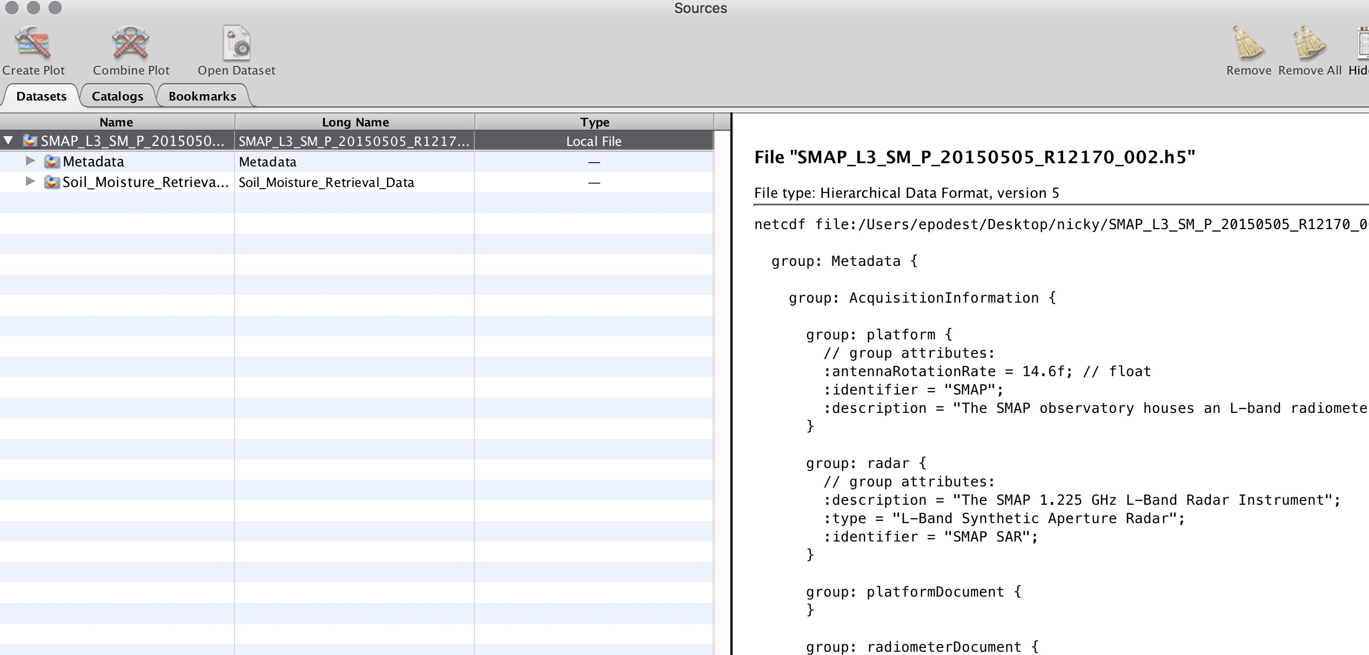Double click on an archive to see the files within it
* 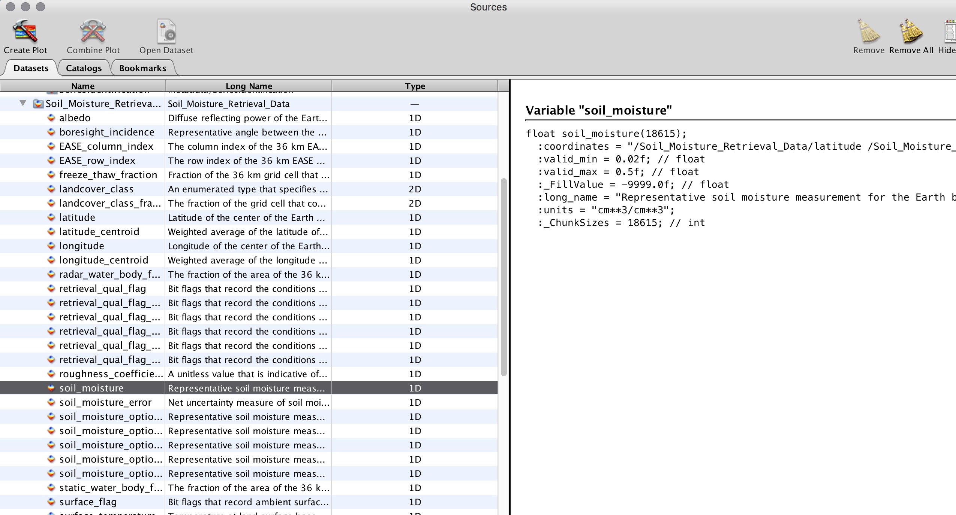Click on **soil moisture** to see the characteristics or metadata of the file in the right-hand window
* 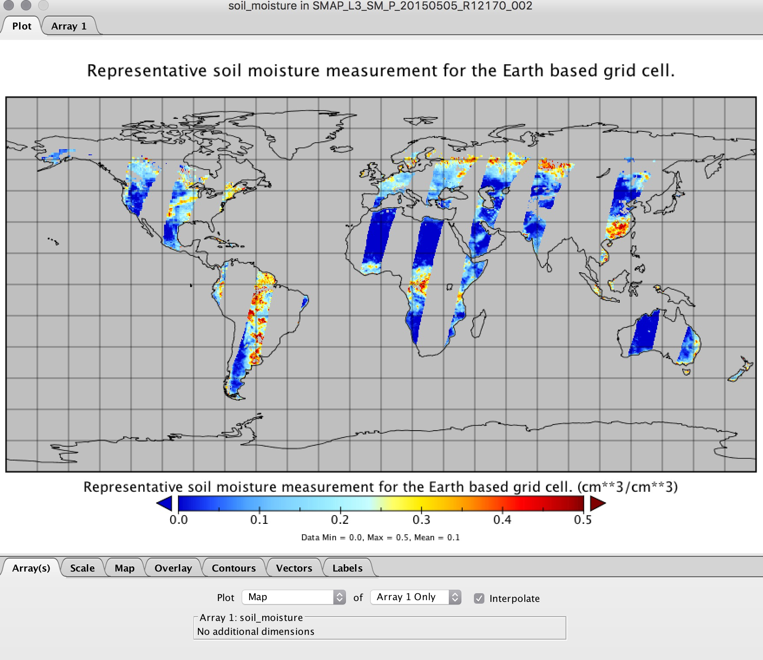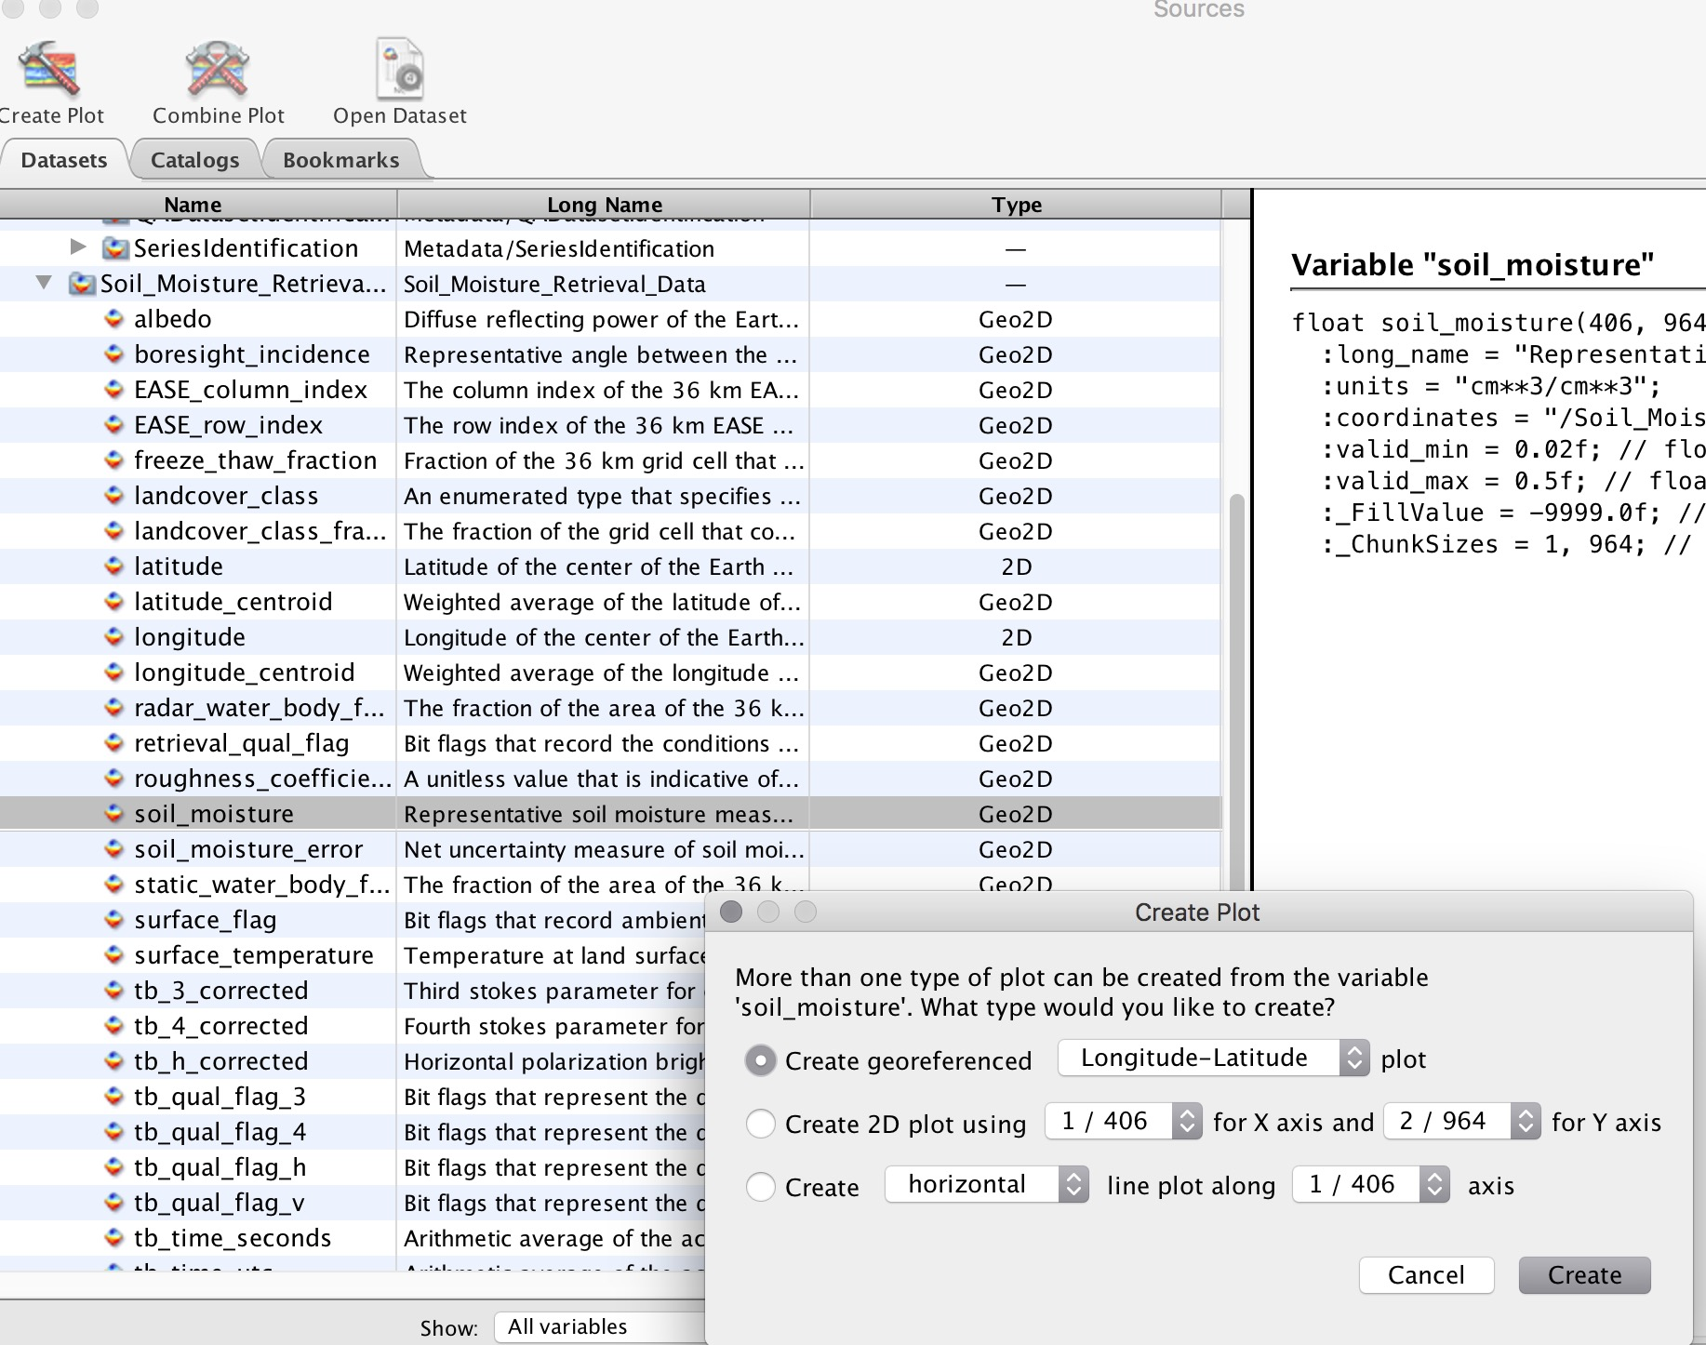Open the file as a map by double-clicking on the soil moisture file
* 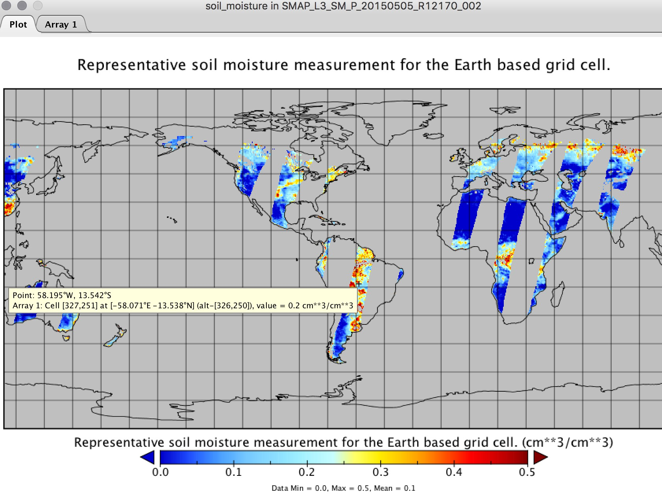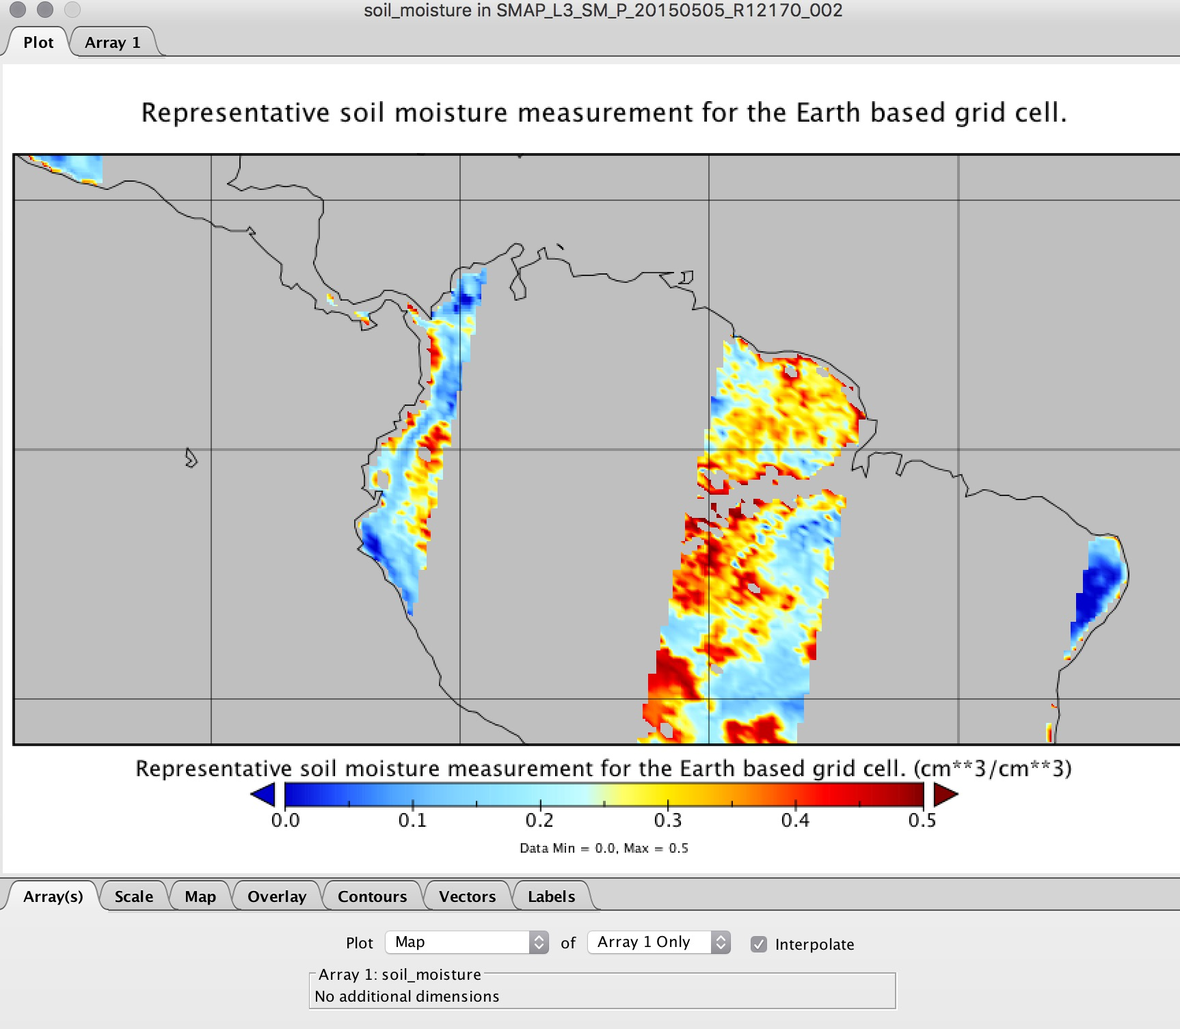To see the pixel value, place the curser over the point of interest and click **Alt**
* To zoom in on an area, go to the top menu and select **Plot-Zoom in**
* 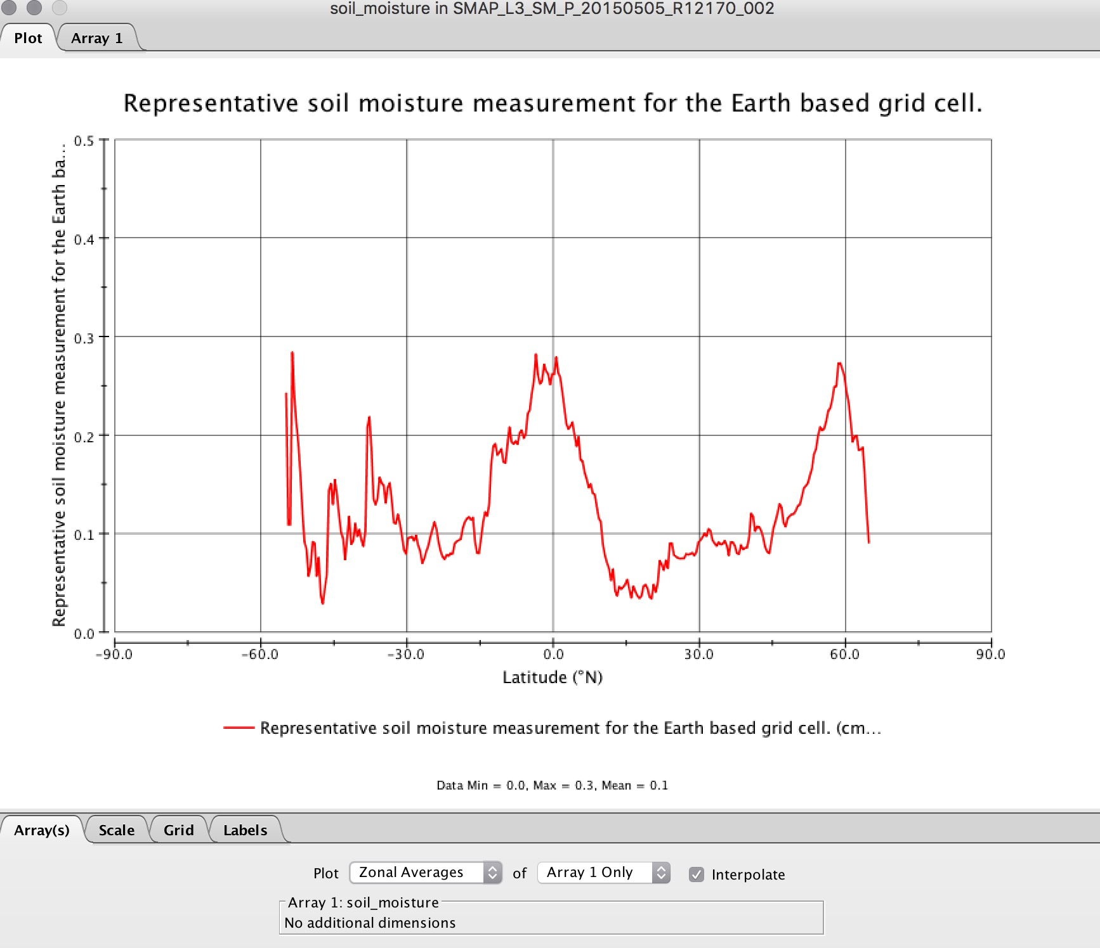In the lower window, select **Array-Plot** to create a plot of soil moisture as a function of latitude
* Click on the tab option on the top that says **Array** to see the values in the file
* To save a file in a different format (e.g. .png, .tiff, .pdf), select **File** > **Save As** from the main menu

**Part 3B: Extracting SMAP Soil Moisture Values**

* Go to the U.S. Flood and Drought Monitor tool from Princeton University: <http://stream.princeton.edu/CONUS4FDM/WEBPAGE/interface.php?locale=en>
  + 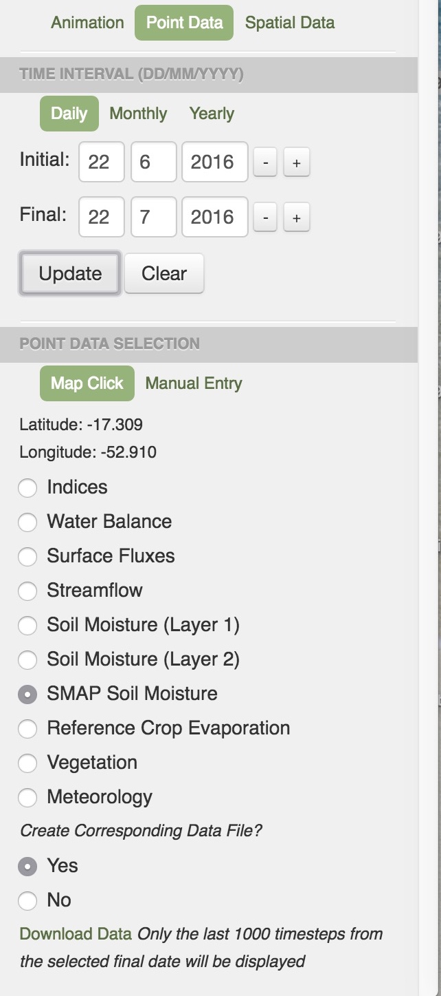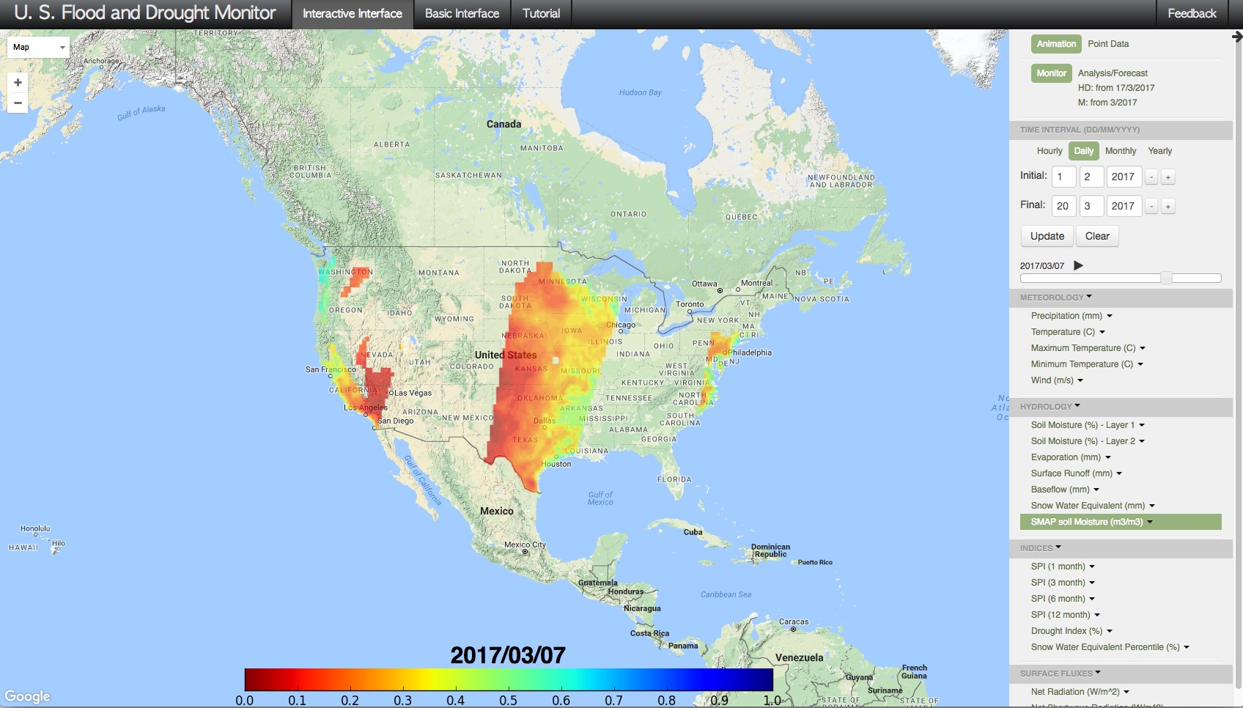This is the most direct way to extract SMAP soil moisture values
* In the upper-right window, select **Point Data**
* In the next section under **Time Interval**, specify the period of interest that you would like: **soil moisture**
  + Note that SMAP soil moisture data is available as of mid-April 2015
* In the next section, select **SMAP soil moisture** and click on the map over your point of interest
  + You may also manually specify your latitude/longitude using the **Manual Entry** option
* Under **Create Corresponding Data File** select **yes**
* Click on **Download Data** at the very bottom
* The data are downloaded directly onto your computer as a text file
* From the same page, download SMAP soil moisture data as well as vegetation and/or meteorological data for the same point
* Plot them and explore any correlations